Reducing Energy Costs Using Thermal Mass in Refrigerator
Student Team Members:  Isabel Price (Lead)  Matthew Manuel  Brent Marin  Caleb Mok  Kalino Ruiz  Faculty Advisors:  Dr. Keith Yi  Sargon Ishaya | 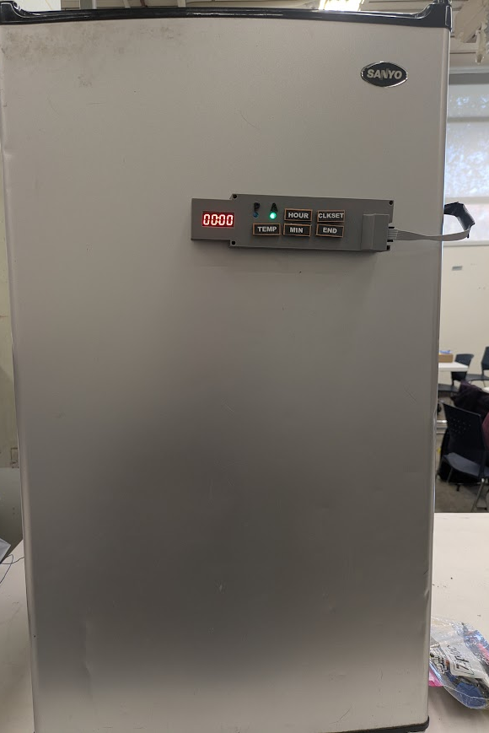  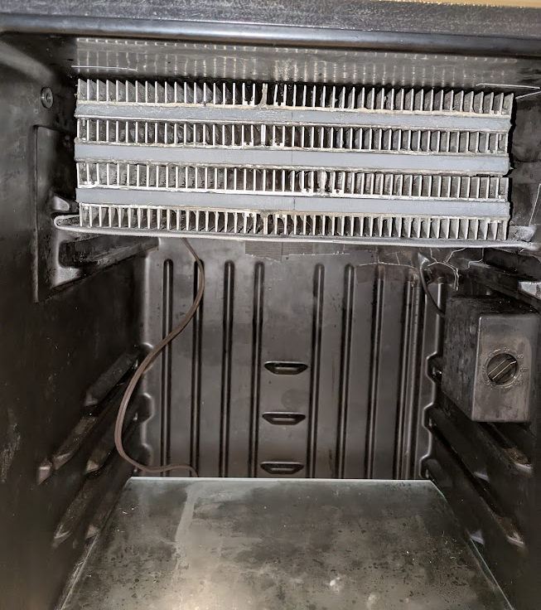
Project Objectives:
We implemented a passive cycle assembly to a refrigerator that blows air over a thermal mass to maintain a safe internal temperature during the peak utility rates, reducing electricity cost, and a microcontroller to control the active and passive modes.

- Utilize thermal storage to shift load away from peak time of use duration while maintaining safe refrigeration temperatures
- Evaluate performance through energy consumption of both active and passive cooling cycles
- Calculate money saved through minimizing energy usage during peak hours
- Evaluate the air velocity profile of the passive cooling cycle

Significance:
This smart refrigerator improves environmental sustainability through reducing electricity load and carbon emissions during peak utility rate periods.

Project Results:
- The fan successfully cycles on when the temperature is below 40°F until the chamber temperature lowers to 37°F.
- The expected energy savings are 24.0 kWh/year based on initial tests.
- The resulting cost savings are $12.60 per year.
- The velocity profile was determined using an anemometer with an average velocity of 1.14 m/s.

Sponsors:
Thank you to Dr. Keith Yi, Sargon Ishaya, Desmond Cheung, Christopher Price, and Dr. Hussameddine Kabbani for their support throughout the design and fabrication of our senior design project.

